Madingley Retreats Enquiry Form

Please use this form to make initial contact about a booking.
You can email it to retreats@madingleychurch.org

Contact Details

Your name:
Telephone number: Email address:

Your Retreat or Quiet Day

Your organisation:
Purpose of booking:
Day retreat / PCC Away Day / Quiet Day / Residential Retreat
Other:
Rough idea of numbers attending:
Suggested date(s):

What resources might you need?
- Tea and coffee facilities (in the church)
- Use of the organ
- Things requisite and necessary for Holy Communion
- Access to the Village Hall
- Access to a room at Madingley Hall (we’ll put you in touch with the right people for you to make arrangements)

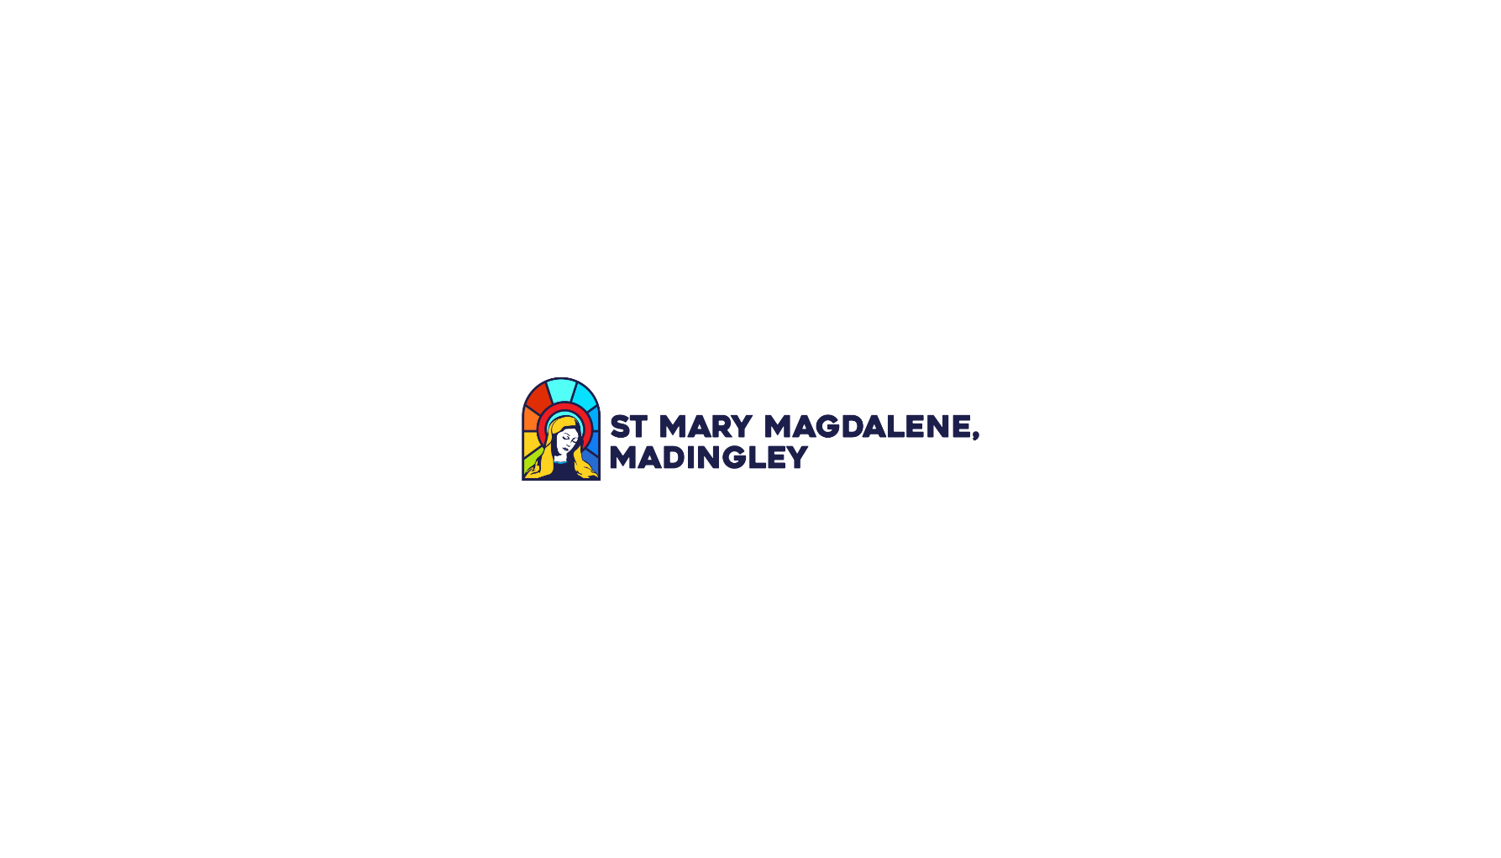
Please return this form to retreats@madingleychurch.org

